9. Travelling Salesman Problem
Aim
To write a Python program to solve the Travelling Salesman Problem (TSP) using brute-force permutation.
Procedure
- Represent cities and their distances using a matrix.
- Select a starting city.
- Generate all possible routes.
- Calculate the total distance of each route.
- Select the route with minimum distance.
- Display the shortest route and distance.
Program
from itertools import permutationscities = ['A', 'B', 'C', 'D']distance = [ [0, 10, 15, 20], [10, 0, 35, 25], [15, 35, 0, 30], [20, 25, 30, 0]]start = 0min_distance = float('inf')best_route = Nonefor route in permutations(range(1, len(cities))): path = (start,) + route + (start,) total = 0 for i in range(len(path) - 1): total += distance[path[i]][path[i+1]] if total < min_distance: min_distance = total best_route = pathprint("Best Route:")print(" -> ".join(cities[i] for i in best_route))print("Minimum Distance:", min_distance)
Output: 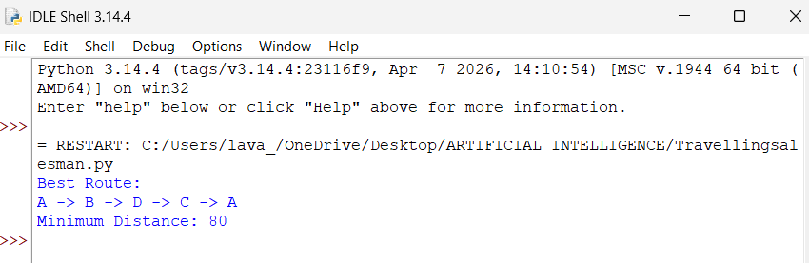

Result
Thus, the Travelling Salesman Problem was successfully solved by finding the minimum-distance route.

